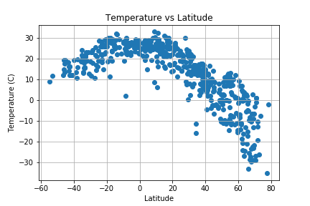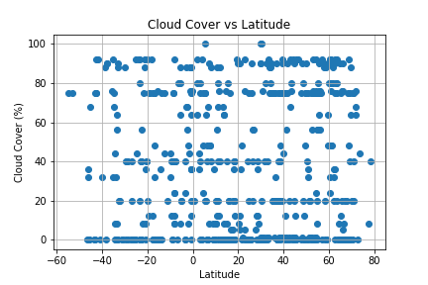The temp vs latitude chart contains the most defined trend which are the hottest temperatures at or around the equator and much colder in the Northern most latitudes. This seasonal temp differential between the Northern and Southern hemisphere makes sense since it’s early spring in the Northern hemisphere and early fall in the Southern hemisphere. In addition, it’s daytime in the Northern hemisphere when the sample was taken vs night in the Southern which I believe means Northern temps are skewed higher for the particular time of day the sample was taken.

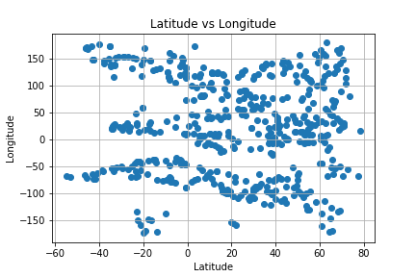The next trend I found interesting is the trend in the cloud cover chart on the left. Here there is extreme grouping around even numbers like 0%, 20%, and 40% etc. I believe this is because there is no effective way to measure cloud cover except human observation and of course humans can’t distinguish between 38% and 39% so they just go with the round number ie 40%.

The final trend I identified is present in all of the charts. There seems to be more clustering of plots in the Northern Hemisphere vs the Southern Hemisphere across the board. These are plots of the closest cities to co-ordinates. I believe there is just less landmass in the far Southern Hemisphere and it’s probably also populated with less cities and people. I plotted latitude vs longitude chart on the left to confirm that there is more cities in the sample in the Northern hemisphere.

I think all of this data should be measured over a historical time frame to make it more comparable. We are taking a snapshot of the wind essentially across the world however there could be a large storm system across the whole of the US skewing the data upwards in a fairly large and wide band. This is not the case as the highest windspeed is just over 16 kph, amazingly low. For temperature we are comparing daytime temp in one hemisphere vs nighttime temp in the other which could be a difference of 10C +. I would take all these measurements the same time of day local time over the last, say 50 years. I would also like to see what happens when you keep longitude fixed.

